**Simple Calculator**

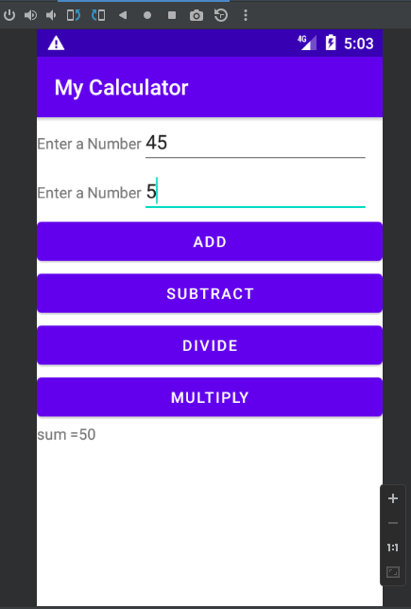

package com.solobin.myappu;

import androidx.appcompat.app.AppCompatActivity;

import android.annotation.SuppressLint;

import android.os.Bundle;

import android.view.View;

import android.widget.Button;

import android.widget.EditText;

import android.widget.TextView;

import android.widget.Toast;

public class MainActivity extends AppCompatActivity {

Button b,b1,b2,b3;

EditText e1,e2;

TextView t1;

@SuppressLint("WrongViewCast")

@Override

protected void onCreate(Bundle savedInstanceState) {

super.onCreate(savedInstanceState);

setContentView(R.layout.*activity_main*);

e1=findViewById(R.id.*ed1*);

e2=findViewById(R.id.*ed2*);

b=findViewById(R.id.*btn*);

b1=findViewById(R.id.*btn1*);

b2=findViewById(R.id.*btn2*);

b3=findViewById(R.id.*btn3*);

t1=findViewById(R.id.*res*);

b.setOnClickListener(new View.OnClickListener() {

@Override

public void onClick(View view) {

String val1=e1.getText().toString();

String val2=e2.getText().toString();

Integer x=Integer.*parseInt*(val1);

Integer y=Integer.*parseInt*(val2);

Integer sum=x+y;

t1.setText("sum ="+sum);

}

});

b1.setOnClickListener(new View.OnClickListener() {

@Override

public void onClick(View view) {

String val1=e1.getText().toString();

String val2=e2.getText().toString();

Integer x=Integer.*parseInt*(val1);

Integer y=Integer.*parseInt*(val2);

Integer sub=x-y;

t1.setText("subtract ="+sub);

}

});

b2.setOnClickListener(new View.OnClickListener() {

@Override

public void onClick(View view) {

String val1=e1.getText().toString();

String val2=e2.getText().toString();

Integer x=Integer.*parseInt*(val1);

Integer y=Integer.*parseInt*(val2);

Integer Div=x/y;

t1.setText("Divide ="+Div);

}

});

b3.setOnClickListener(new View.OnClickListener() {

@Override

public void onClick(View view) {

String val1=e1.getText().toString();

String val2=e2.getText().toString();

Integer x=Integer.*parseInt*(val1);

Integer y=Integer.*parseInt*(val2);

Integer mul=x*y;

t1.setText("Multiple ="+mul);

}

});

}

}

<?xml version="1.0" encoding="utf-8"?>

<TableLayout xmlns:android="http://schemas.android.com/apk/res/android"

xmlns:app="http://schemas.android.com/apk/res-auto"

xmlns:tools="http://schemas.android.com/tools"

android:layout_width="match_parent"

android:layout_height="match_parent"

tools:context=".MainActivity">

<TableRow android:layout_width="469dp">

<TextView

android:layout_width="wrap_content"

android:layout_height="wrap_content"

android:text="@string/aa"

app:layout_constraintBottom_toBottomOf="parent"

app:layout_constraintEnd_toEndOf="parent"

app:layout_constraintStart_toStartOf="parent"

app:layout_constraintTop_toTopOf="parent" />

<EditText

android:id="@+id/ed1"

android:layout_width="211dp"

android:layout_height="wrap_content" />

</TableRow>

<TableRow>

<TextView

android:layout_width="wrap_content"

android:layout_height="wrap_content"

android:text="@string/aa"

app:layout_constraintBottom_toBottomOf="parent"

app:layout_constraintEnd_toEndOf="parent"

app:layout_constraintStart_toStartOf="parent"

app:layout_constraintTop_toTopOf="parent"

tools:ignore="HardcodedText" />

<EditText

android:id="@+id/ed2"

android:layout_width="wrap_content"

android:layout_height="wrap_content"

android:inputType="text" />

</TableRow>

<Button

android:layout_width="wrap_content"

android:layout_height="wrap_content"

android:text="ADD"

android:id="@+id/btn"

/>

<Button

android:layout_width="wrap_content"

android:layout_height="wrap_content"

android:text="subtract"

android:id="@+id/btn1"

/>

<Button

android:layout_width="wrap_content"

android:layout_height="wrap_content"

android:text="Divide"

android:id="@+id/btn2"

/>

<Button

android:id="@+id/btn3"

android:layout_width="294dp"

android:layout_height="wrap_content"

android:text="Multiply" />

<TextView

android:id="@+id/res"

android:layout_width="wrap_content"

android:layout_height="wrap_content"

android:text="Result"

app:layout_constraintBottom_toBottomOf="parent"

app:layout_constraintEnd_toEndOf="parent"

app:layout_constraintStart_toStartOf="parent"

app:layout_constraintTop_toTopOf="parent" />

</TableLayout>